## Beijer Exter T70-bl

### Specifications

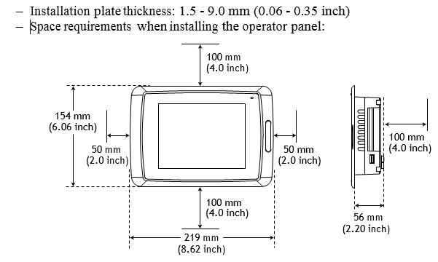

Figure 2‑1: Dimensions

1. Unpack and check the delivery (see Figure 2‑2). If damage is found, notify the supplier.

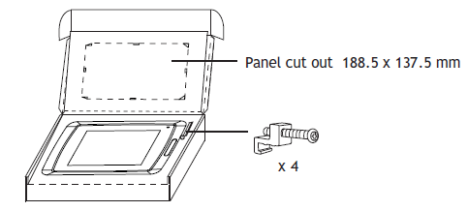

Figure 2‑2: Delivery and contents

NOTE

Place the operator panel on a stable surface during installation. Dropping it or letting it fall may cause damage.

1. Place the panel cut-out where the operator panel is to be situated, draw along the outer sides of the holes and cut according to the markings (see Figure 2‑3).

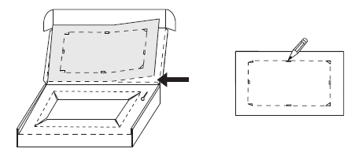

Figure 2‑3: Panel cut-out

1. Secure the operator panel in position, using all the fastening holes and the provided brackets and screws (see Figure 2‑4).

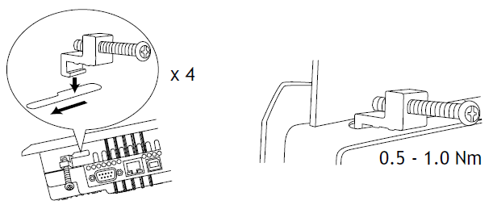

Figure 2‑4: Fastening holes and brackets

1. Connect the cables in the specified order.

**CAUTION**

**Ensure that the operator panel (ref. A, Figure 2‑5) and the controller system have the same electrical grounding (reference voltage level), otherwise errors in communication may occur.**

1. Use an M5 screw and a grounding conductor (as short as possible) with a cross-section of minimum 2.5 mm2 (ref. B).

**CAUTION**

* **Use only shielded communication cables**
* **Separate high voltage cables from signal and supply cables (ref. C)**
* **The operator panel must be brought to ambient temperature before it is started up. If condensation forms, ensure that the operator panel is dry before connecting it to the power outlet (ref. D).**
* **Ensure that the voltage and polarity of the power source is correct.**

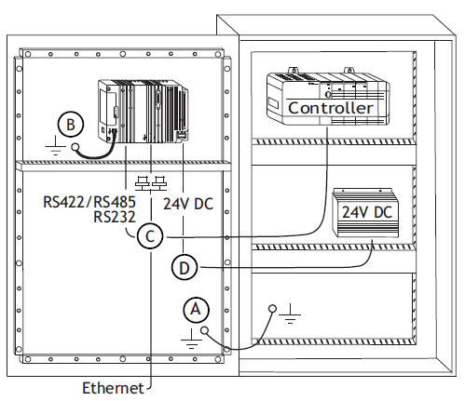

Figure 2‑5: Cable connections

1. Carefully remove the laminated film over the operator panel display, to avoid static electricity that could damage the panel.

### Mode switches

**CAUTION**

* **All mode switches (see Figure 2‑6) must be in OFF position during operator panel use.**
* **The mode switches should not be touched unless by qualified personnel.**

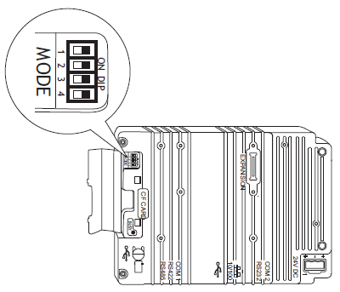

Figure 2‑6: Mode switches

### Connections to the controller

For information about the cables to be used when connecting the operator panel to the controller, please refer to the help file for the driver in question.

### Other connections and peripherals

**CAUTION**

**When using a compact flash card, do not remove the card when the busy indicator is illuminated.**

Cables, peripheral equipment and accessories must be suitable for the application and its environment. For further details or recommendations, please refer to the supplier (see references).

### Communication ports

**RS-232:**

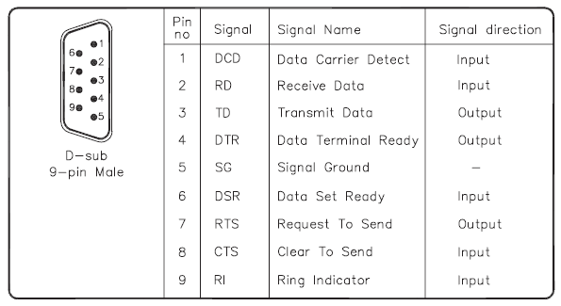

**RS-422/485:**

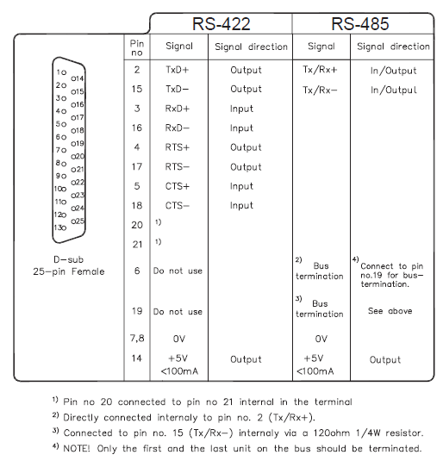

**USB:**

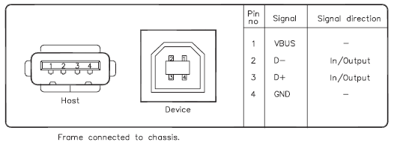

**Ethernet:**

